MCSA notes

<http://www.networkedminds.com/>

exam schedule - <https://www.microsoft.com/en-us/learning/exam-70-410.aspx>

https://www.exam-labs.com/exam/70-410

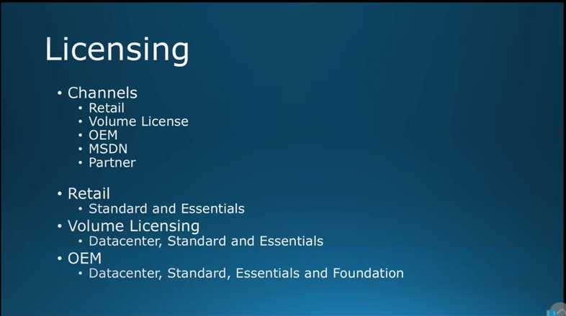

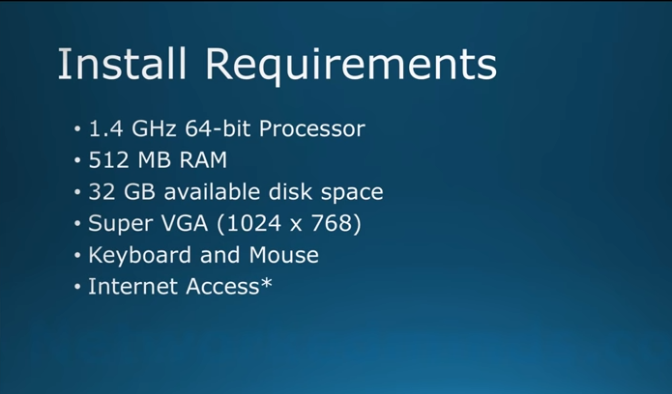

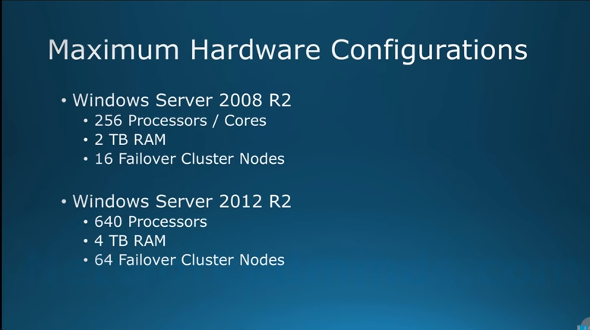

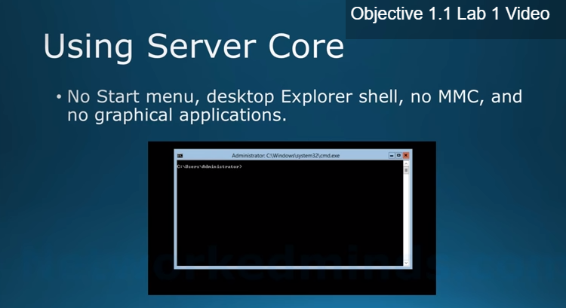

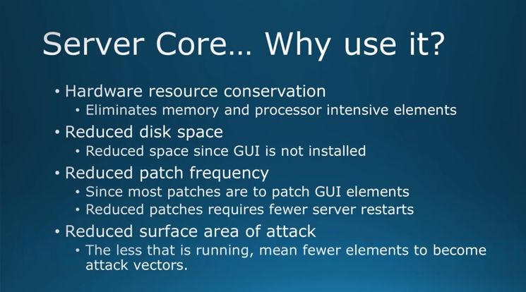

**No GUIs, so it can be used as a print server**

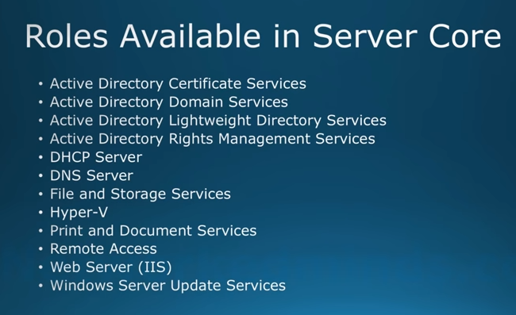

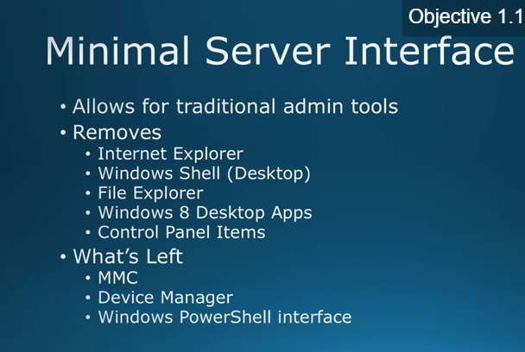

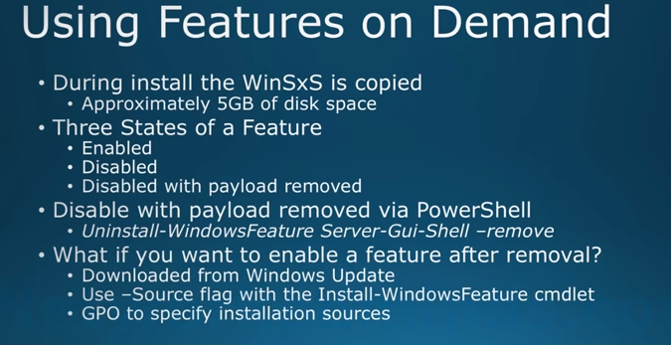

**WinSxS = windows side by side installation, you can install feature without providing the media**

**You can export WinSxS features in the folder exported to a share, and then we can specify which features we want to install**

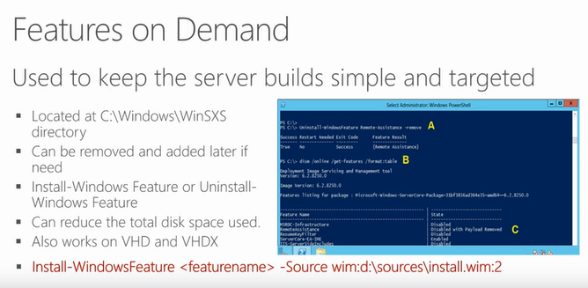

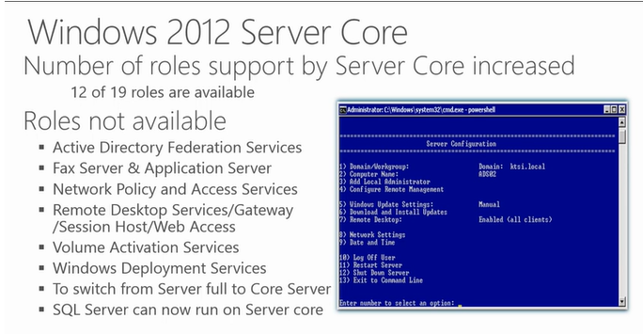

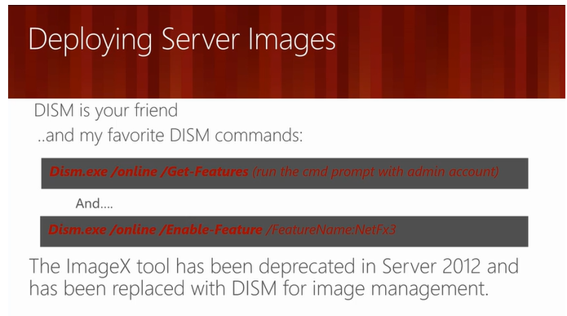

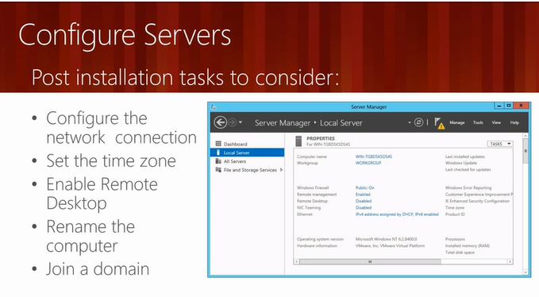

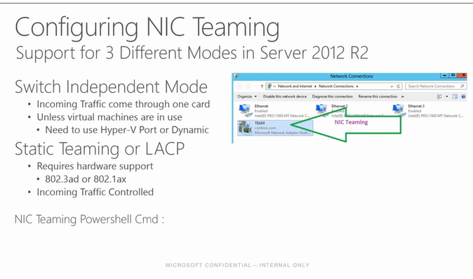

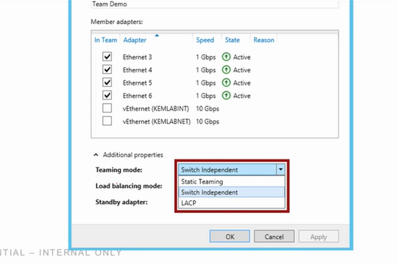

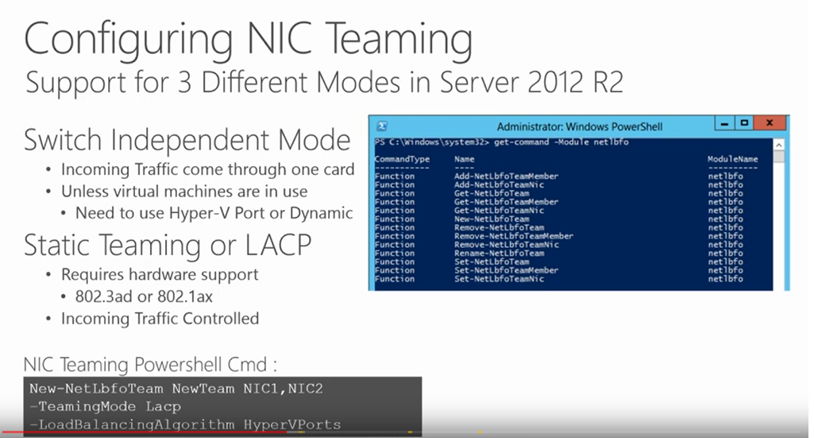

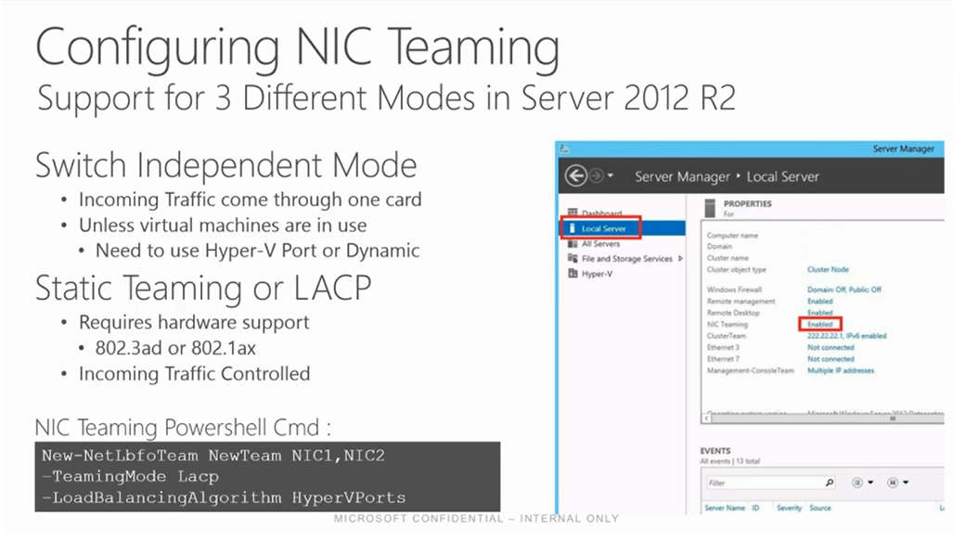

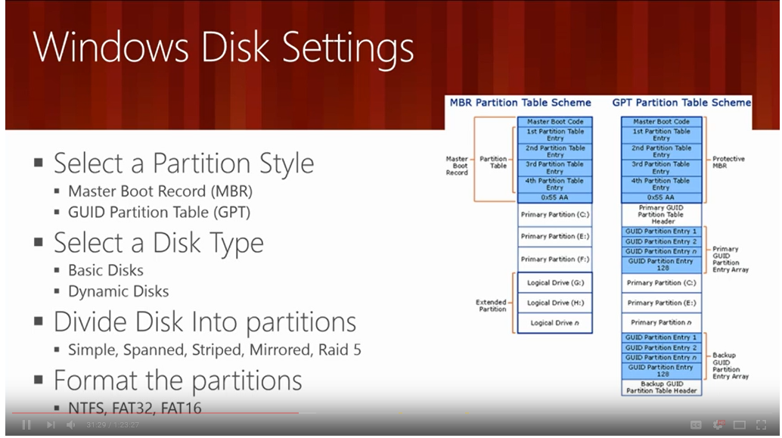

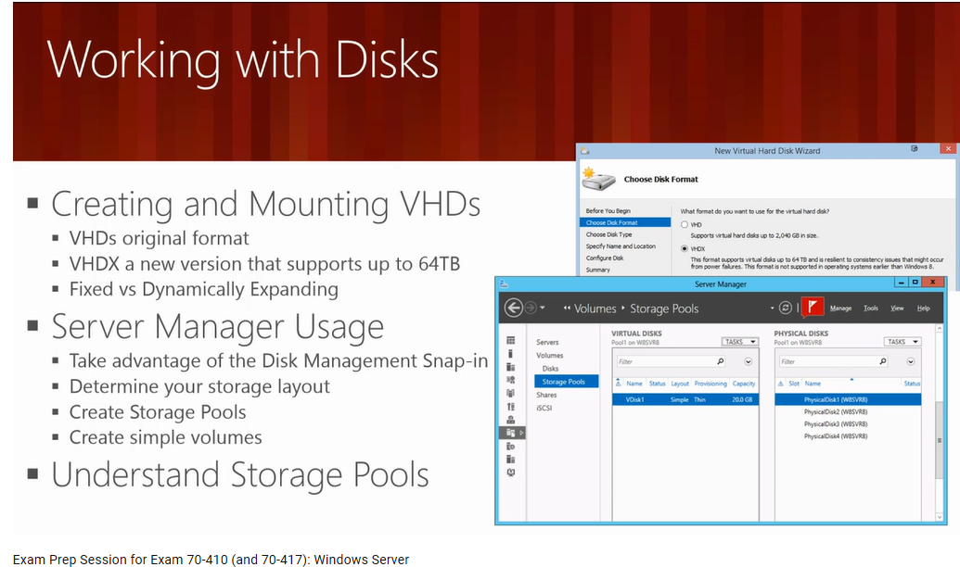

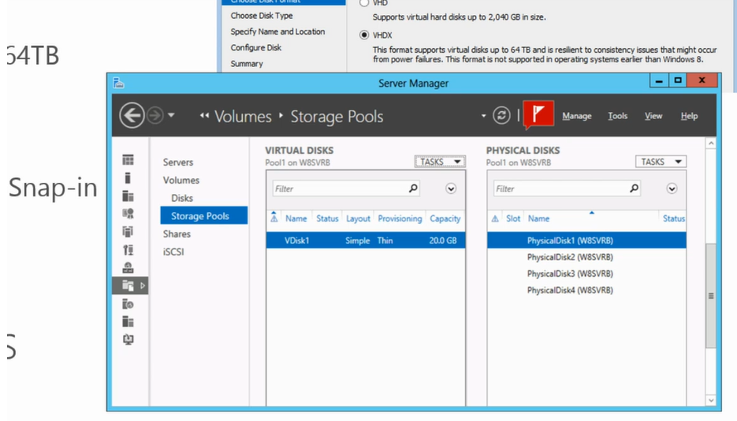

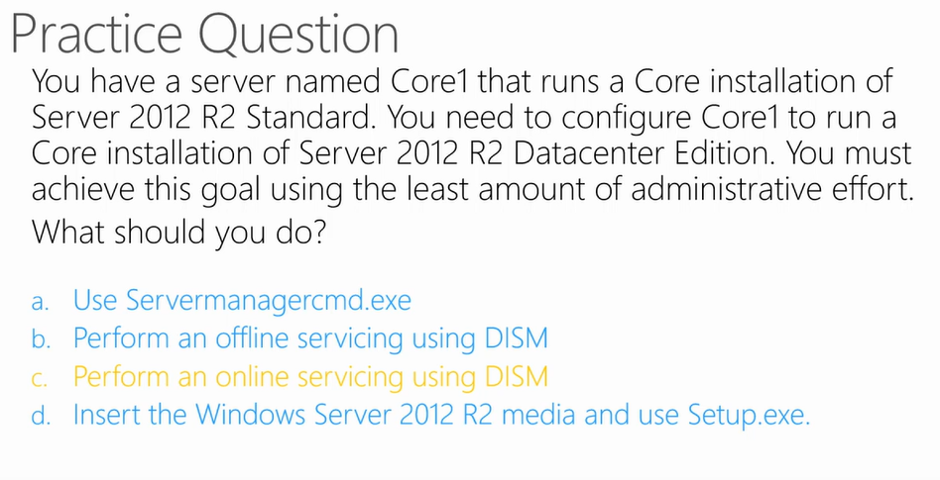

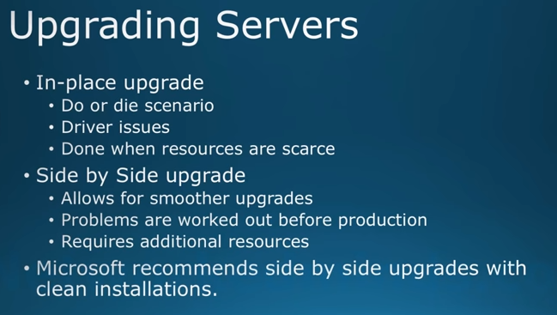

**Microsoft encourages side by side upgrades because problems are worked out before production, however it requires additional resources like 2 servers**

**Easiest is side by side**

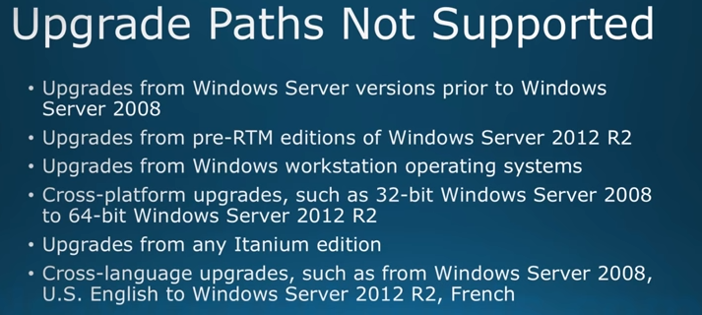

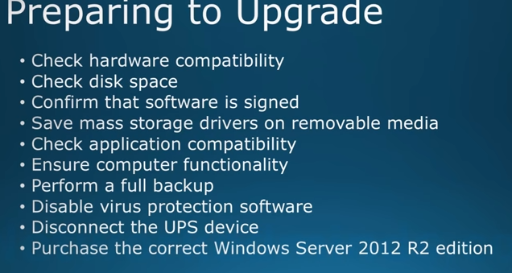

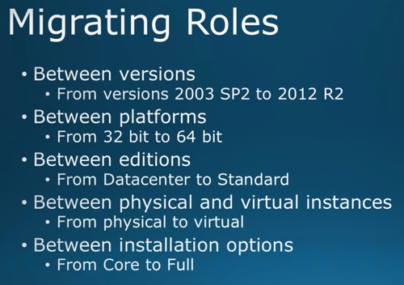

**Creating Server roles and features**

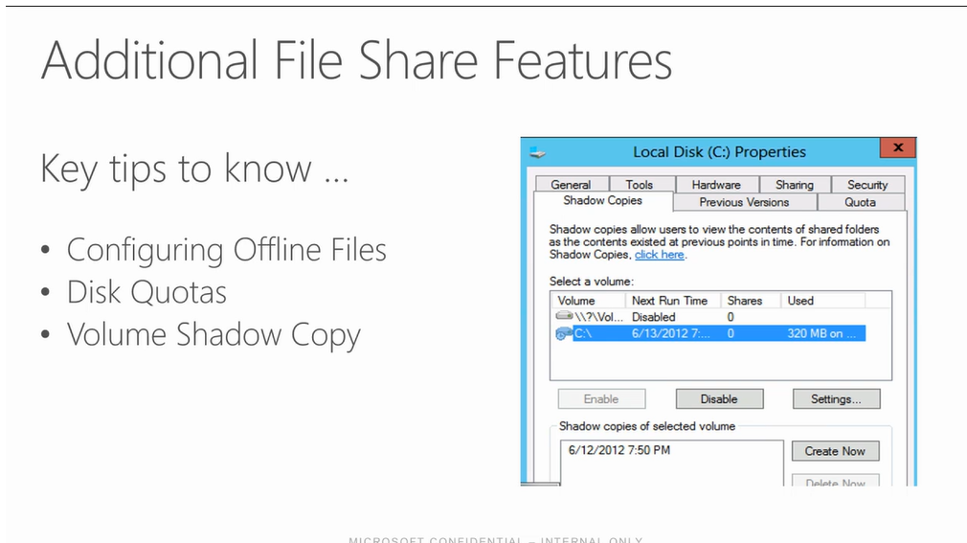

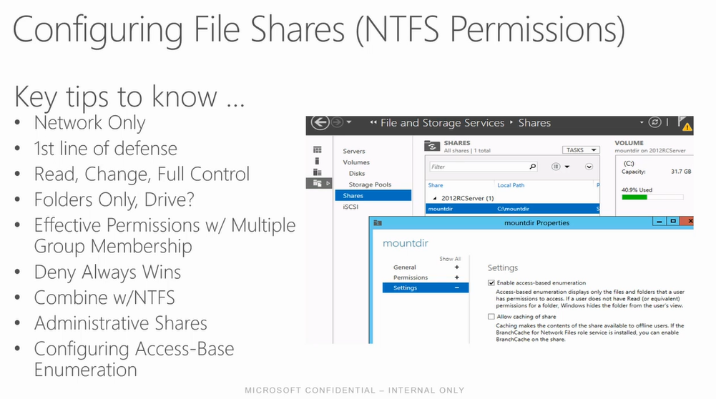

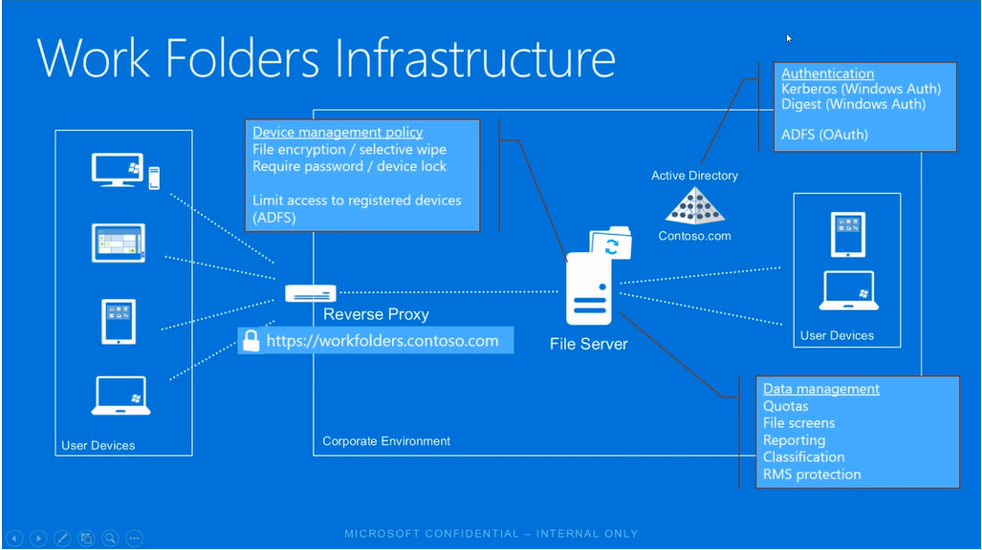

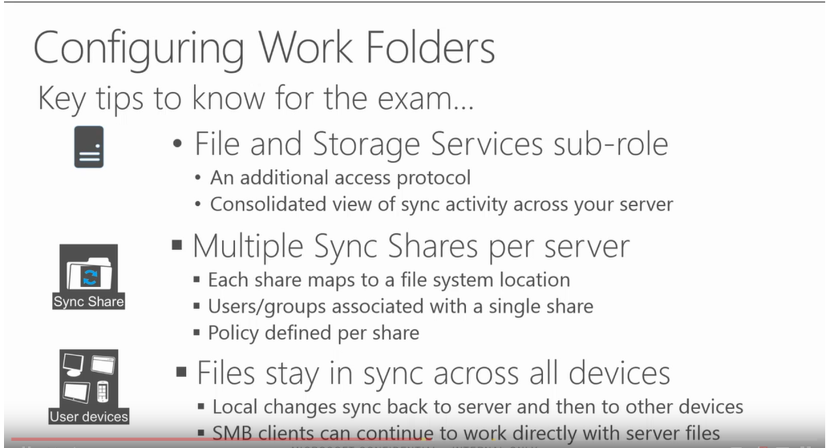

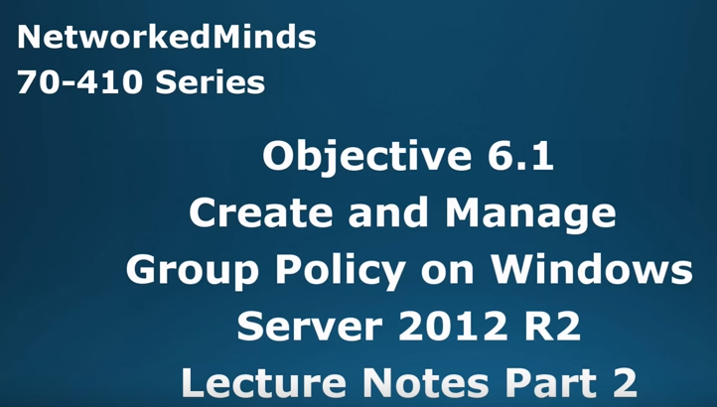

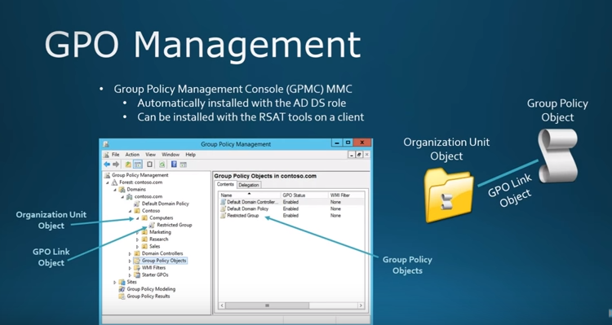

This video is part two of two videos where we cover Group Policy Objects for Objective 6.1 Create and Manage Group Policy 70-410. We being by discussing Group Policy management and the components of Group Policy. Group Policy had three main parts; the GPO itself, the Organizational Unit to be applied to, and the GPO link object to apply the Group Policy to the OU. Then we discuss how a Group Policy Object can be scoped down. When a Group Policy is scoped down, it means we are limiting its application of its settings. We have three main mean of scoping it down; the first is the links that are created to the Group Policy Object and we have the option to link, delete the link or disable the link. The next is security filtering, which is selectively applying it to a particular security group or primary principal. The last is using WMI filtering, which is a way to have the end computer or user perform a SQL type query and if it’s true the Group Policy Object is applied. The WMI filtering is the most granular since you can create an almost limitless number of ways the Group Policy can be applied conditionally. We then cover the different types of settings found inside of a Group Policy of Policies and Preferences. We also learn how everything is broken down to either Computer or User Objects for application. We then look at the three states to a Group Policy setting which is; Not Configured (default), Enabled, and Disabled. The last topic in relation to Group Policy is Local GPOs and the options we now have for local users. In operating systems prior to Vista and Windows Server 2008 we only had one GPO that we could create at the local GPO level. This applied to all users including administrators. In Vista or Windows Server 2008 of later operating systems we can now choose between specific local users, administrators or non-administrators. This allows maximum flexibility for creating local GPOs.

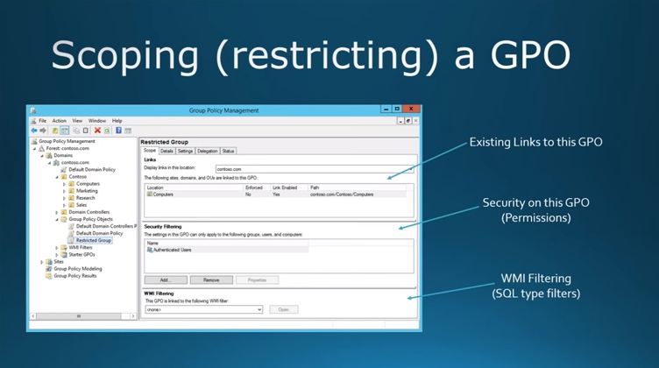

**Policies**

**Preferences**

**Exam notes**

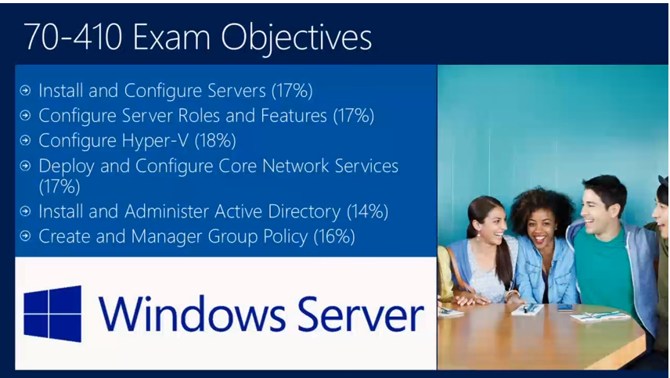

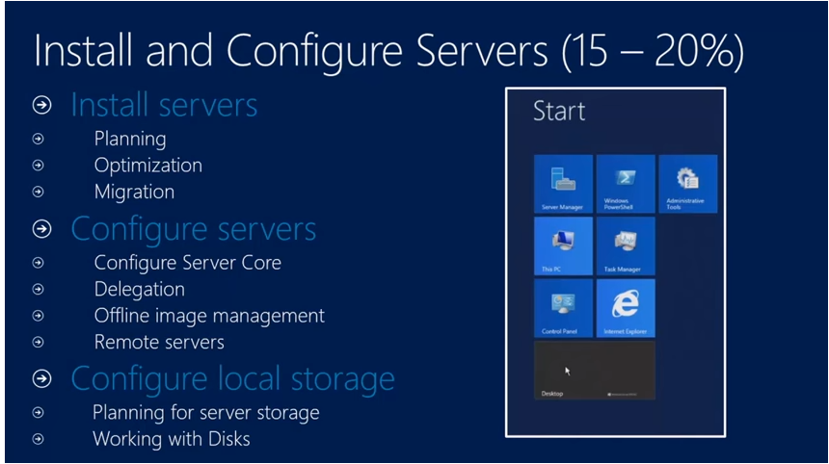

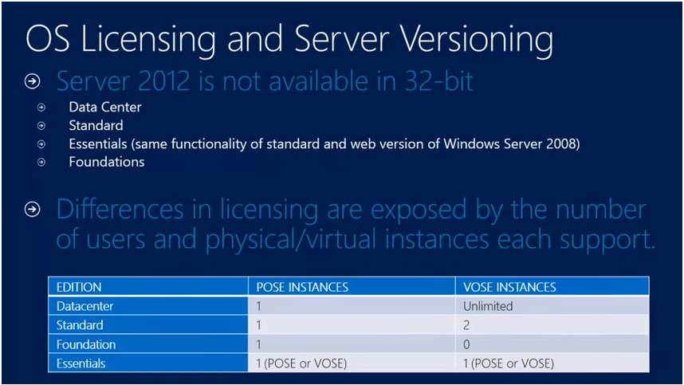

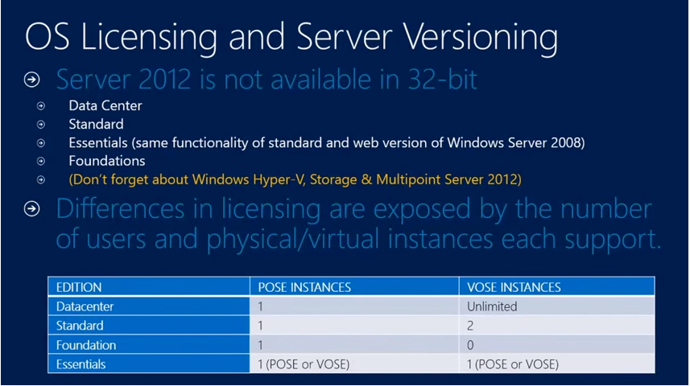

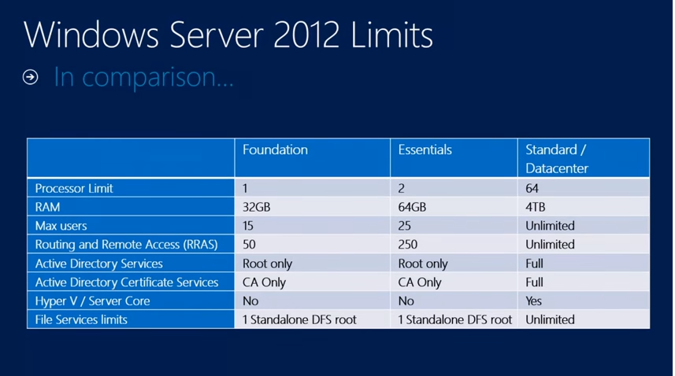

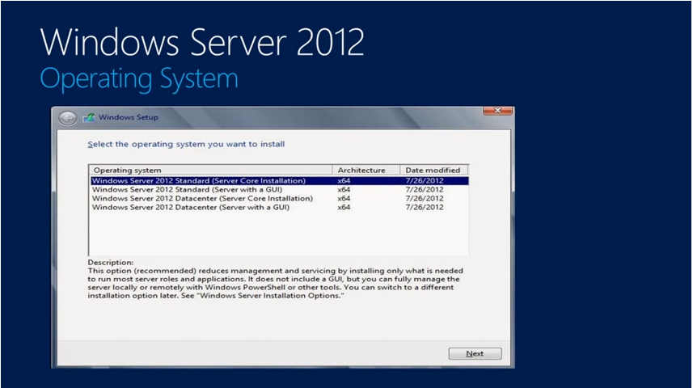

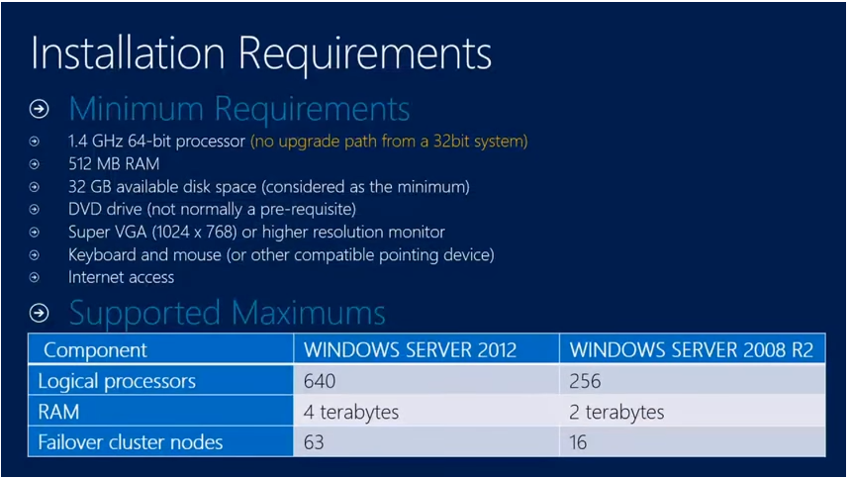

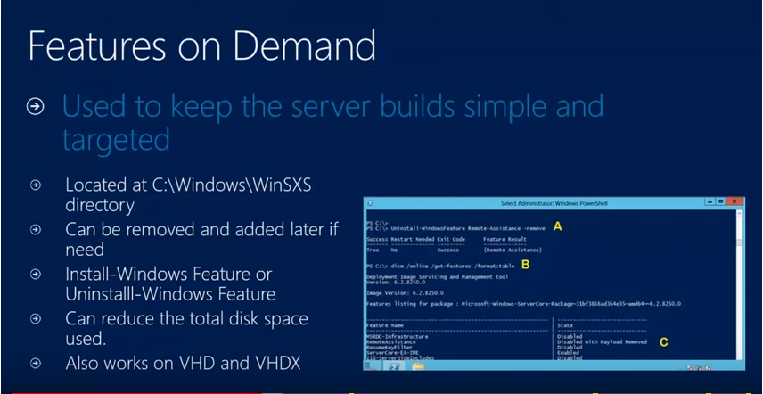

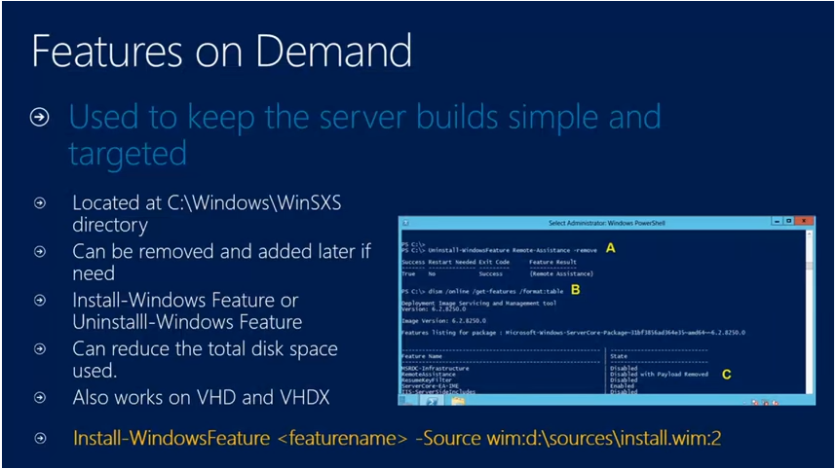

**User powershell command to “get-help” to find commands for install feature if you do not know**

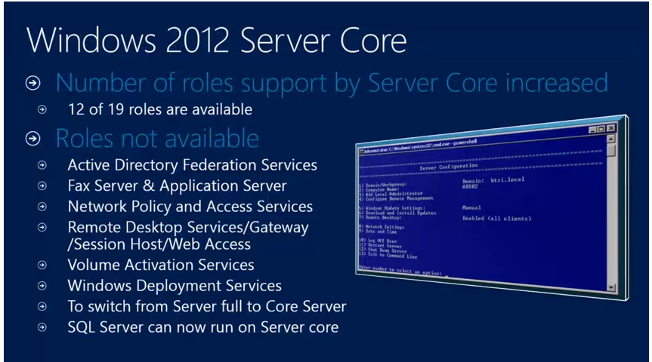

**Sconfig – server config**

1. Change to the system drive.
2. Type Sconfig.cmd, and then press ENTER. The Server Configuration tool interface opens:

**Winrm -** Windows Remote Management (WinRM) is the Microsoft implementation of [WS-Management Protocol](https://msdn.microsoft.com/en-us/library/aa384470(v=vs.85).aspx), a standard Simple Object Access Protocol (SOAP)-based, firewall-friendly protocol that allows hardware and operating systems, from different vendors, to interoperate.

**IF I want to convert a server core installation to a GUI installation**

**Uninstall-WindowsFeature Server-Gui-Shell, Server-Gui-Mgmt-Infra**

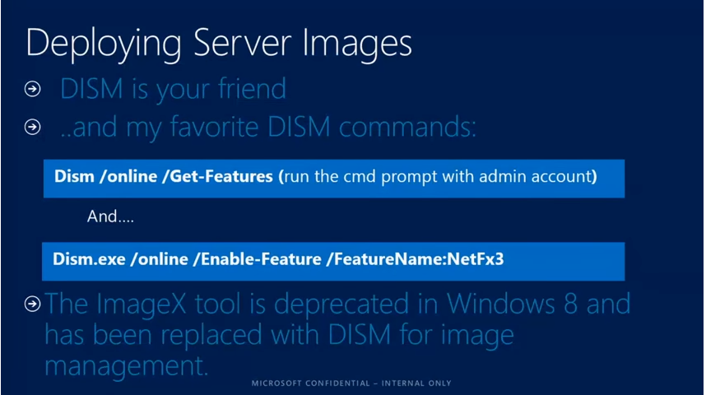

**DISM-** Deployment Image Servicing and Management (**DISM**) is a command-line tool that is used to mount and service Windows images before deployment. You can use **DISM** image management commands to mount and get information about Windows image (.wim) files or virtual hard disks (VHD)

Deployment Image Servicing and Management (**DISM**.exe) is a **command**-line tool that can be used to service and prepare Windows images, including those used for Windows PE, Windows Recovery Environment (Windows RE) and Windows Setup.**DISM** can be used to service a Windows image (.wim) or a virtual hard disk (.vhd or .vhdx)

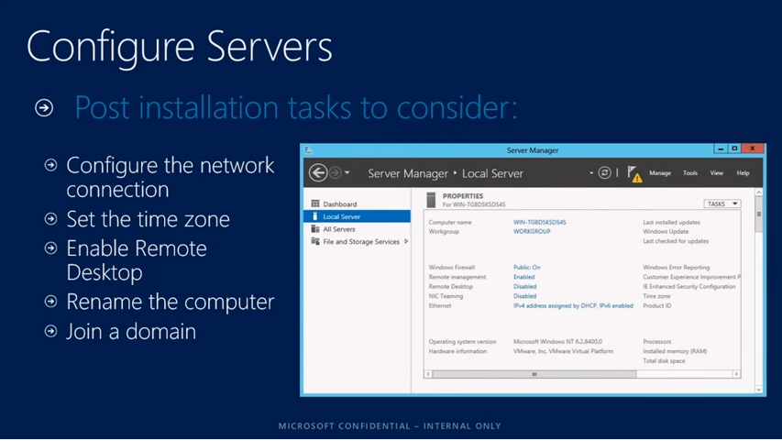

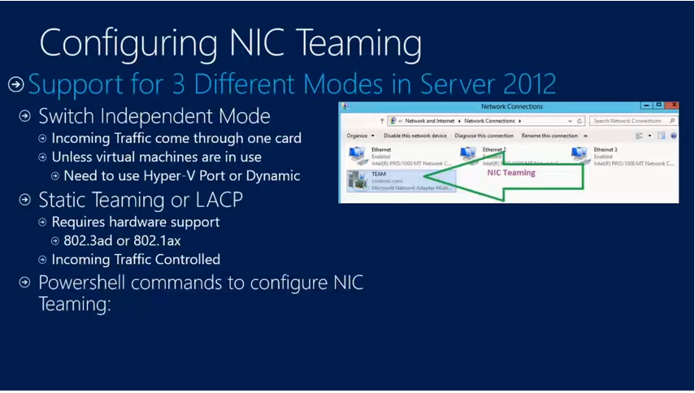

**LACP- link aggregation control protocol -** Link Aggregation Control Protocol. Within the IEEE specification, the Link Aggregation Control Protocol (**LACP**) provides a method to control the bundling of several physical ports together to form a single logical channel.

**What actual NICs are apart of it**

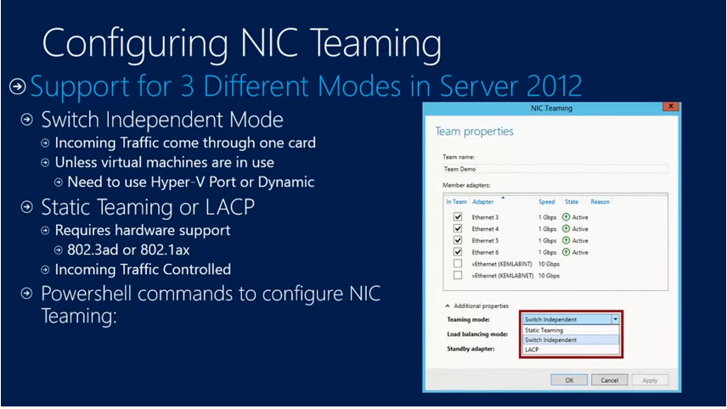

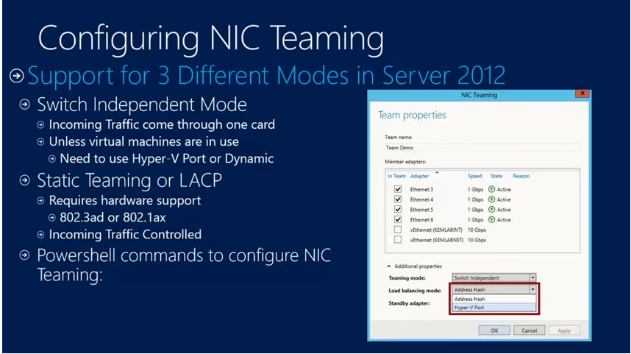

**Address hash divides traffic by ip address or ports**

**Hyper-v divides the traffic by the vm you are using**

**Allows you to manage traffic, load balancing mode called dynamic in 2012 R2 only**

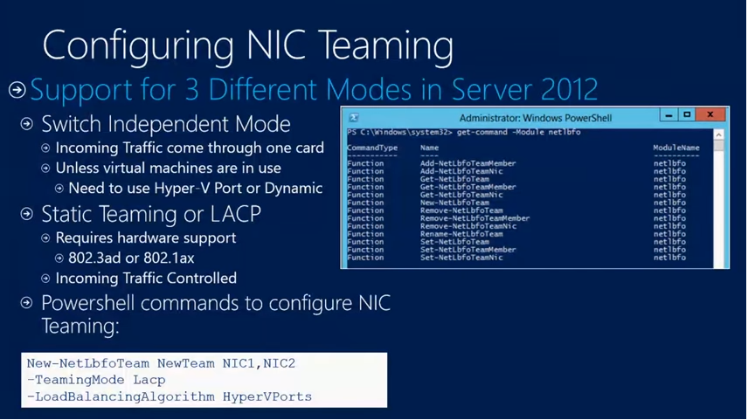

**Use powershell command below to find commandlets for NIC teaming**

**Get-command -Module netlbfo**

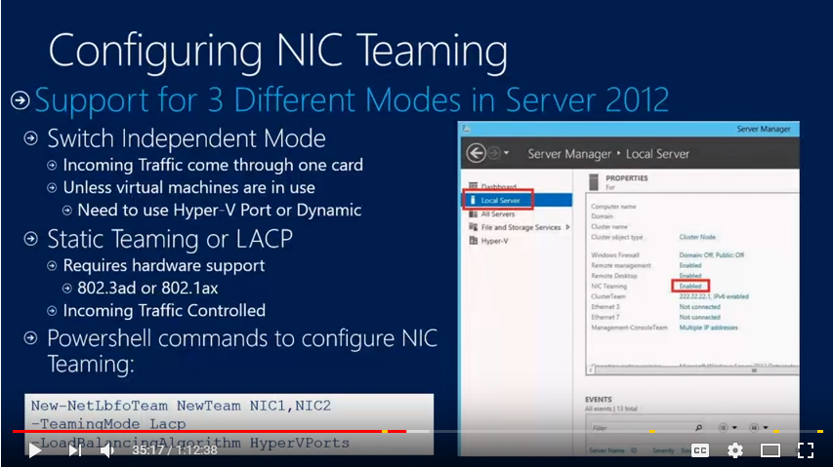

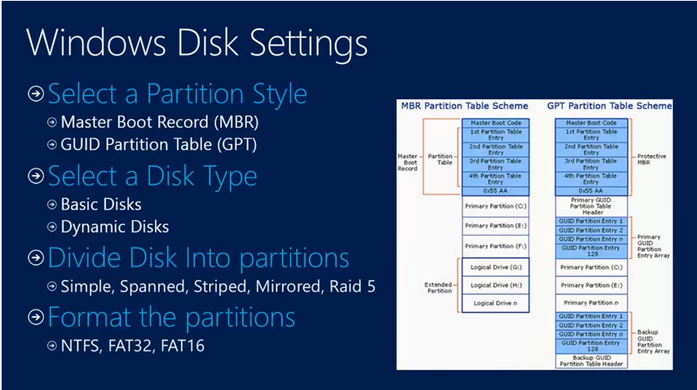

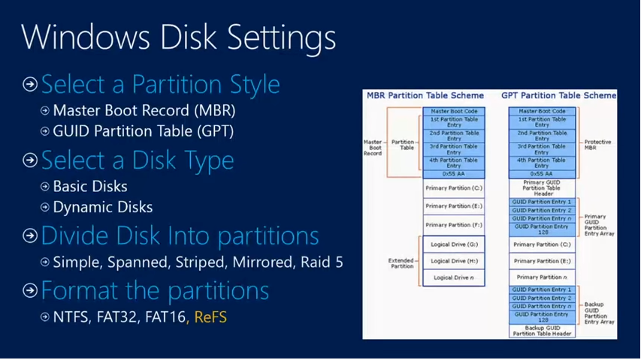

**REFs take away need for recovery**

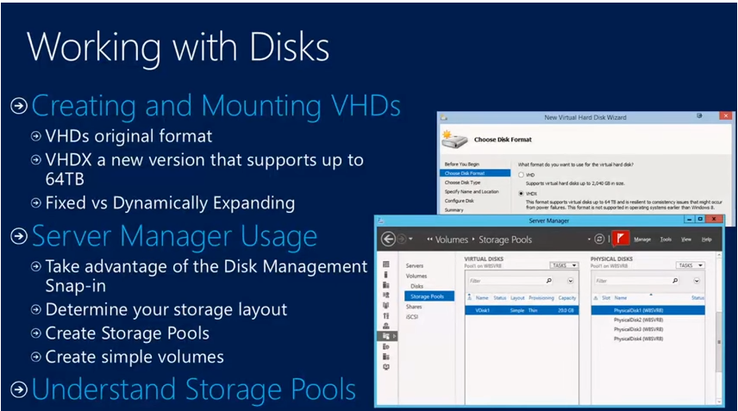

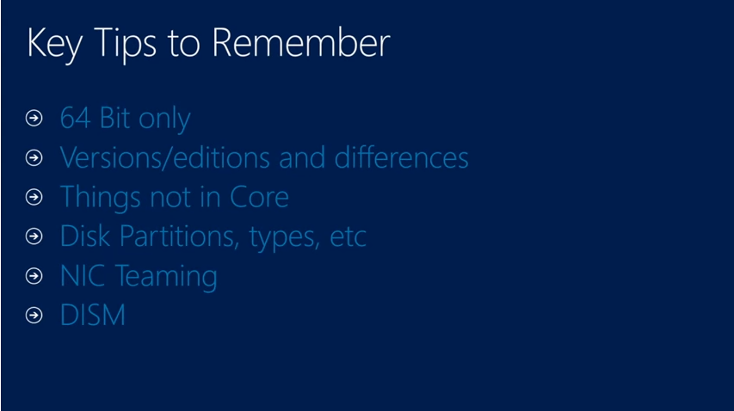

**Question on hardware then you are switch dependent, if no questions involve hardware then your NIC teaming is switch independent**

**DISM is your friend**

